FIONA GREEN ROBERTSON
WE ARE SO GLAD YOU WERE BORN!
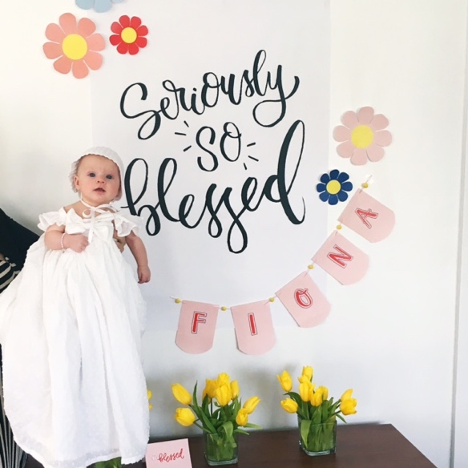

WHEN/WHERE/HOW?
DECEMBER 8, 2015
AMERICAN FORK HOSPITAL
(OTHER DETAILS)

PEOPLE WHO CAME
- GREENS
- ROBERTSONS
- FRIENDS

SPIRITUAL EXPERIENCES
1) ANDREA AND ALISON
2) DAD’S IMPRESSIONS
3) BABY BLESSING

GIFTS YOU BRING TO OUR FAMILY
1) FUNNY
2) LOVES EVERYONE
3) “LITTLE, BUT FIERCE”

MY BIRTH STORY

- WHEN/WHERE/HOW?

- PEOPLE WHO CAME

- YOUR NAME MEANS/OUR NAMES FOR YOU

- SPIRITUAL EXPERIENCES

- GIFTS YOU/WE BRING

